
WEb application penetration testing report -dvwa
Capstone Project & Incident Response


March 13, 2026
pREPARED BY: ASHISH KUMAR BISHNOI
INTERN ID: APSPL2627106

Table of Contents
1. Scope 2
2. Network Diagram 4
3. Reconnaissance 5
4. Web Application Testing 7
5. Log Analysis 10
6. Incident Response Simulation 11
7. Risk Summary Table 11
8. Tools Used: 12
9. Summary 12

Scope

Target Application: The target system for this penetration testing exercise is an Ubuntu Server hosting the Damn Vulnerable Web Application (DVWA). DVWA is a deliberately insecure web application designed for security professionals and students to practice web penetration testing techniques in a controlled environment.

Target URL: (http://192.168.6.137/DVWA/)

Testing Objectives:

- Identify security vulnerabilities within the DVWA application.
- Demonstrate how these vulnerabilities can be exploited by an attacker.
- Evaluate the impact of the discovered vulnerabilities.
- Provide remediation recommendations to improve the application's security posture.

In Scope Vulnerabilities:

The following web application vulnerabilities were specifically tested during this engagement:

- SQL Injection (SQLi) – Testing input fields for database query manipulation vulnerabilities.
- Cross-Site Scripting (XSS) – Identifying reflected or stored scripts that execute in a user's browser.
- Command Injection – Testing for improper input validation that allows execution of system commands.
- Brute Force Attacks – Assessing authentication mechanisms for weak password protections or lack of rate limiting.

Testing Environment:

All testing activities were conducted in a controlled lab environment using a host-only isolated virtual network. The setup consisted of:

- Attacker Machine: Kali Linux
- Target Machine: Ubuntu Server running DVWA
- Network Type: Virtual Box Host-only Network

This isolated environment ensured that testing activities did not impact external systems, production environments, or live networks.

Network Diagram

Kali (192.168.6.134) → Host-only → Ubuntu DVWA (192.168.6.137)

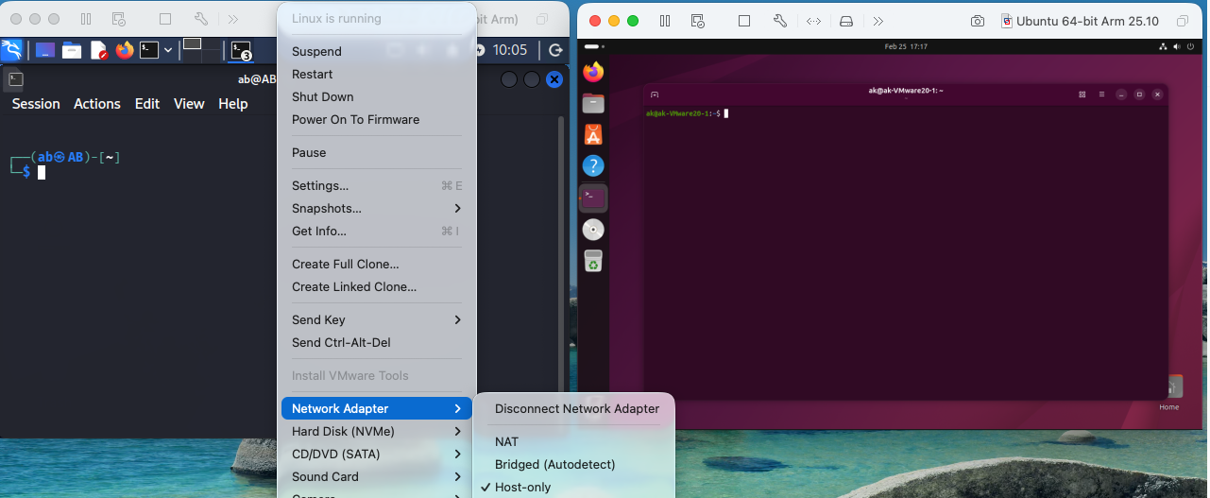

Reconnaissance

- Identify Network: (ip a)

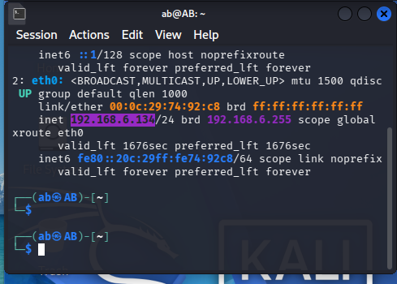

- Host Discovery: ( nmap -sn 192.168.6.0/24)

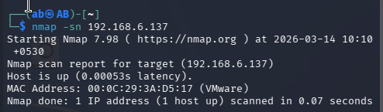

- Port & Service Scan: ( nmap -sV 192.168.6.0/24)

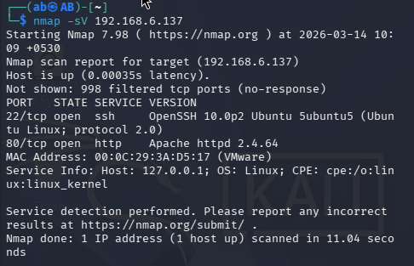

- A ping sweep was performed to identify active hosts in the network.
- Open Ports Identified: 22 (SSH) & 80 (Apache HTTP)

Web Application Testing

The DVWA security is set to low: (http://192.168.6.137/DVWA/security.php)
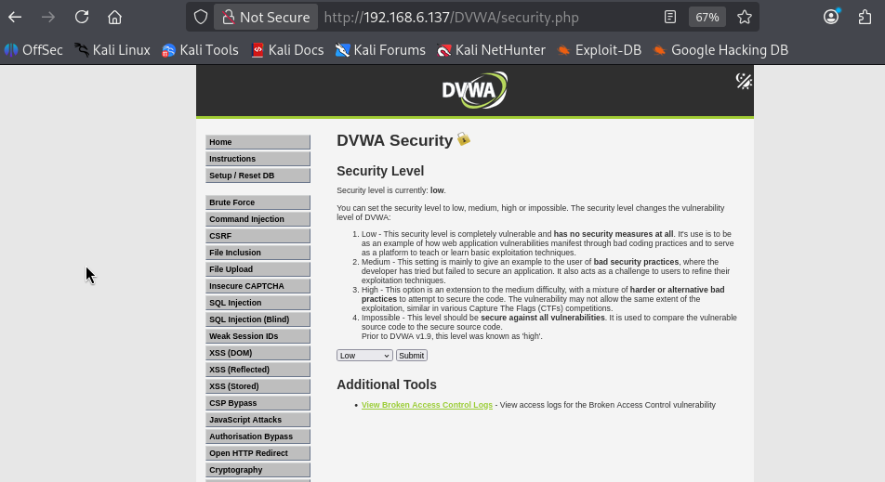

- Finding -SQL Injection

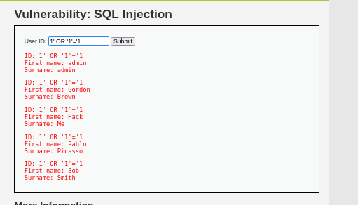

Vulnerability: SQL Injection Severity: Critical
The application fails to validate user input in SQL queries, allowing injection of arbitrary SQL commands.

Payload Used: 1' OR '1'='1

Impact: Attacker can extract database contents, including usernames and passwords.

Another Payloads: 1' UNION SELECT 1, version()#
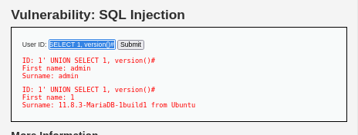

Another Payloads: 1' UNION SELECT user, password FROM users#

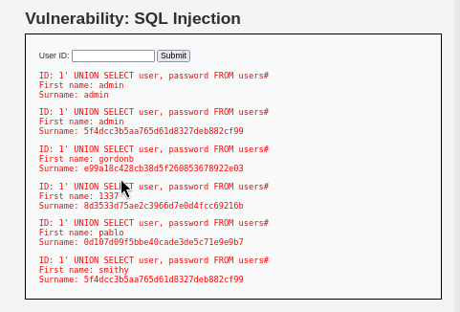

- Finding – Reflected XSS

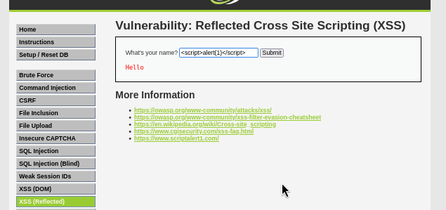

Payload Used: <script>alert(1)</script>
Severity: High
Impact: Allows attacker to execute malicious JavaScript in victim’s browser.

- Finding – Stored XSS

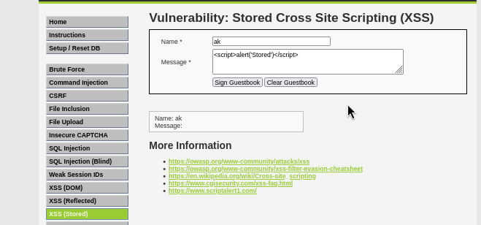

Payload Used: <script>alert('Stored')</script>
Severity: High
Impact: Persistent client-side attack affecting all users.

- Finding – Command Injection:

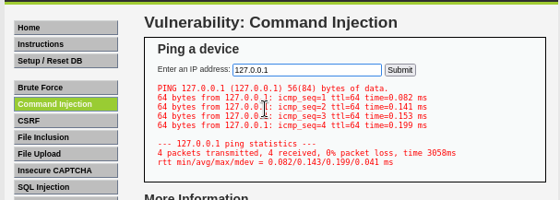

Payload Used: 127.0.0.1 && whoami
Severity: Critical
Impact Remote command execution on server

Log Analysis

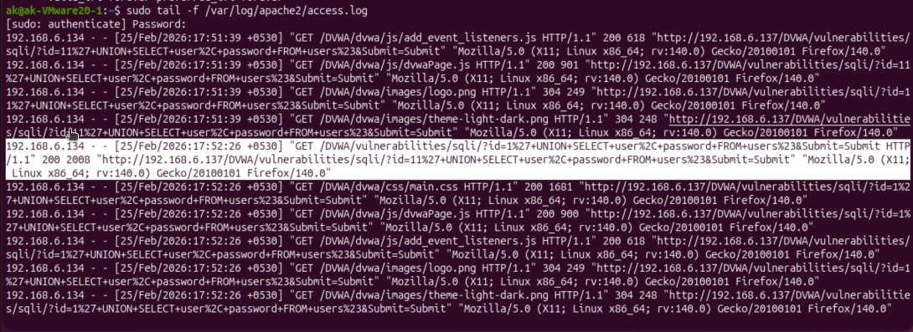

Indicators of Compromise (IOC)

Indicator | Description
Suspicious parameter | Id=
SQL keywords | UNION SELECT
Data extraction attempt | user, password FROM users
Repeated requests | Testing multiple payloads
Source IP | 192.168.6.134

Incident Response Simulation

- Detection: Suspicious SQL payload detected in Apache logs.
- Analysis: Confirmed malicious input attempting authentication bypass.
- Containment: On target machine ( sudo ufw enable & sudo ufw deny from 192.168.6.134)
- Check status: sudo ufw status
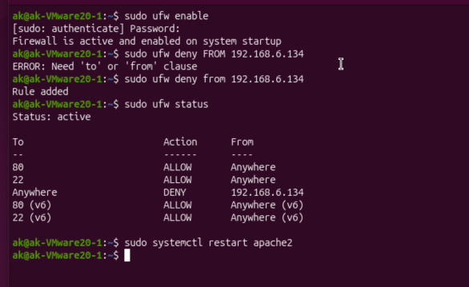
- Eradication: - Increased DVWA security level, changed admin password
- Recovery: sudo systemctl restart apache2

Risk Summary Table
Vulnerability | Severity | Risk Level
SQL Injection | Critical | High
Command Injection | Critical | High
Stored XSS | High | Medium
Reflected XSS | High | Medium

Tools Used:

Kali Linux | Nmap
Hydra | DVWA
Apache Logs | UFW Firewall

Summary
A web application penetration test was conducted against the Damn Vulnerable Web Application (DVWA) hosted on an Ubuntu server. The objective was to identify security weaknesses and demonstrate potential exploitation techniques in a controlled lab environment.
The assessment identified multiple vulnerabilities including SQL Injection, Cross-Site Scripting (XSS), Command Injection, and weak authentication controls. Two critical vulnerabilities could allow attackers to access sensitive database information or execute system commands on the server. Immediate remediation measures are recommended to mitigate these risks.

